Identify Your Lewmar Winch
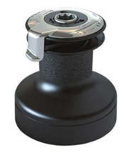
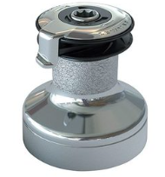
EVO Self Tailing Winches
The Evo Winch is Lewmar's newest winch, and has been in production since late in 2010

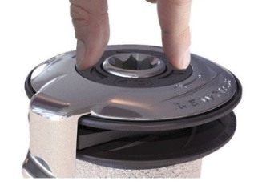

**********************************************************************************************
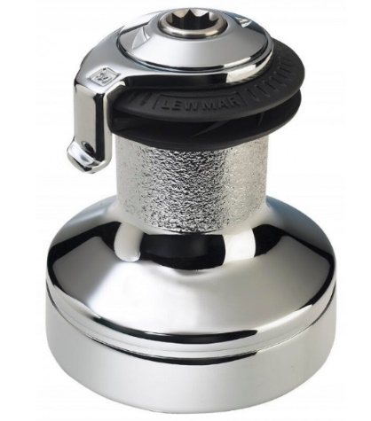
Ocean Self Tailing Winch
Ocean Wavespring self-tailing winches
have been in production since 1992.

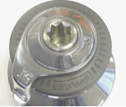

Easily to identified by the chrome, spin-off top cap and spring loaded composite jaws.
Racing versions are identified by an alloy feeder arm and top cap in place of the Ocean's chromed bronze.

***********************************************************************************************

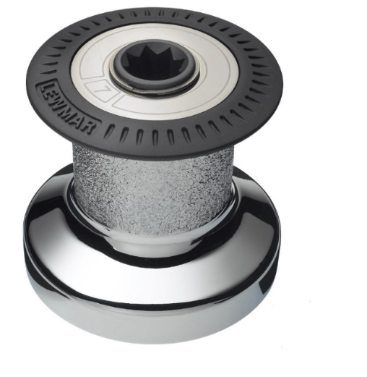
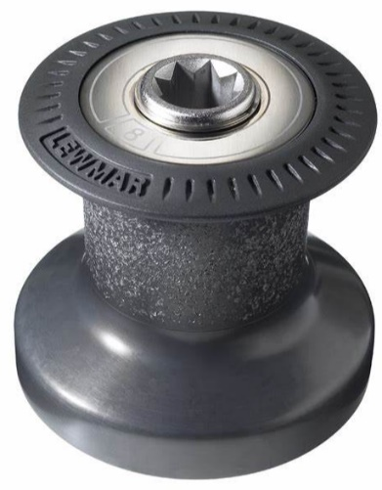
Current Standard Winches
Current Standard Ocean Winches have been
produced from 1992.

Have a gray molded top crown on the drum,
except for Size 6 which has a one-piece metal drum.

***********************************************************************************************

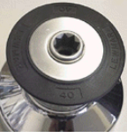
Early Standard Winches
Early Standard Winches were produced between 1982 - 1992

Had a black molded top crown on the drum.
Please note that spares for some sizes are limited.

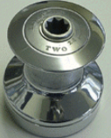

Earlier Standard Winches
Earlier Standard Winches had one-piece drums
Only very limited spares are now available.

***********************************************************************************************

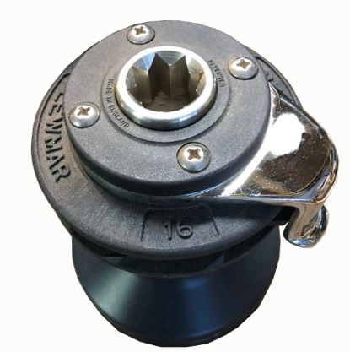
Wavegrip Self Tailing Winches
Wavegrip Self-Tailing Winches were produced between 1983-1991.
and are identified 4 Philips head screws (not Allen head) securing the top cap.
They also have fixed jaws.

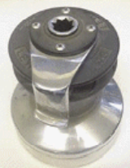
Please note that some winch sizes have only a limited range of spares available.
Wavegrip winches made prior to 1983 were made to imperial dimensions and parts are no longer available these winches have Allen head screws on top cap

***********************************************************************************************

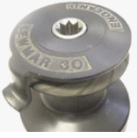
Holdfast Self Tailing Winches
Hold Fast Self-Tailing Winches were produced between 1978 - 1983
in Sizes 16, 30 & 34 and can be identified by their one piece upper
crown and feeder arm that screwed directly on top.
Available spares for these winches are now very limited.

***********************************************************************************************

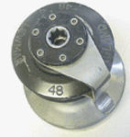
Spring Jaw Winches (The earliest self-tailing winches)
Spring Jaw, were produced between 1975-1977
and had 6 Allen screws securing the top cap.
Available spares for these winches are now very limited.

